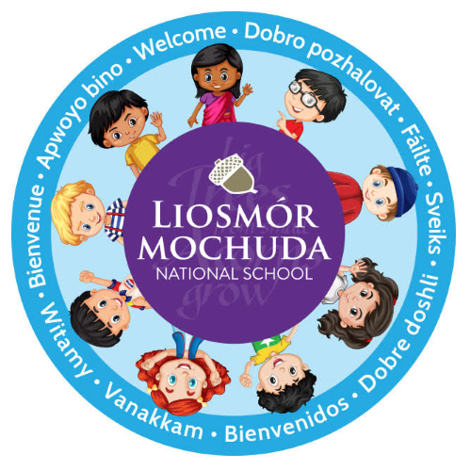

The staff, principal and students identified handwriting and presentation skills as an area to work upon. In September 2020 handwriting and presentation skills were chosen as the areas to focus upon for school self-evaluation. As part of the school self improvement plan a handwriting policy was formulated to enhance handwriting within the school.

The primary purpose of writing is expression and communication. The ultimate aim of the curriculum is that each child would develop a legible, fluent and personal style of handwriting. (English curriculum p.52) As handwriting is a skill it will require practice at regular intervals. Short but regular practice is recommended. Children will develop handwriting skills at different rates. In Liosmór Mochuda NS we encourage the use of the cursive style print in the Junior classes and develop upon this in the middle and senior classes with the introduction of cartridge pens, erasable pens etc. Formal handwriting lessons are conducted in the Junior classes and in all other classes when the need arises. We seek to enable the children to develop their own style and a legible style for use throughout their lives. In Liosmór Mochuda, we encourage children who print handwrite to attain their own handwriting goals based on clarity, fluency, finger spaces etc.

Aims
The policy aims:
- to ensure good letter formation from Junior Infants to Sixth Class.
- to ensure that all children are using the correct pencil grip
- to ensure legibility of all writing to ensure consistency in letter formation from class to class
- to facilitate the presentation of all written work to develop a positive attitude to handwriting to support the school’s self improvement plan for SSE

Writing guidelines
- Preparation: pre-writing activities in Infant classes include scribbling, colouring, rainbow colouring, channelling, tracing, copying, patterns, mazes and activities to help develop fine motor skills
- Pencil grip: Pick up the pencil between the thumb and index finger, flick it back and place the middle finger underneath. Most letters are formed without lifting the pencil off the page, for a few letters (t, i, j, x, F, K, Q, X) two movements will be required, For H, three movements will be required.
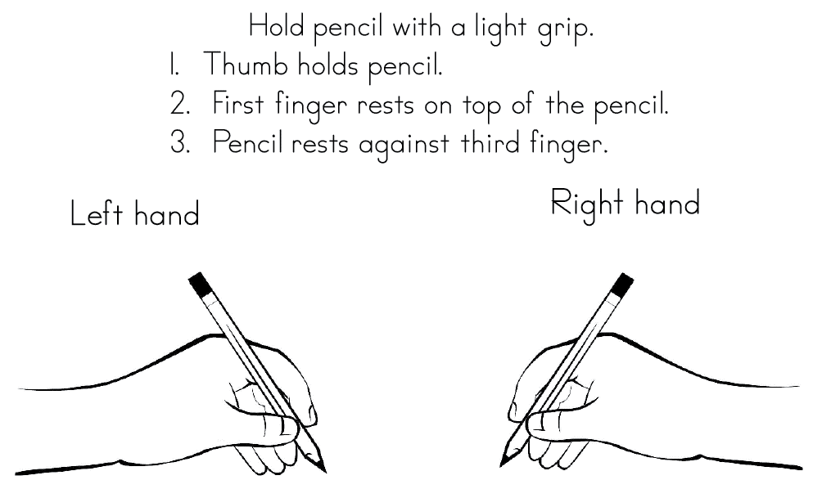

- Posture: Sit at a table with both feet on the floor. Pull the chair in and sit up straight. The non-writing hand should steady the paper.
- Paper angle: Keep the paper/copy to the right/left of your body, depending on whether writing with the right/left hand. Angle the paper/copy, more if writing with the left hand. Place the writing hand below the writing line.
- Practice (letter formation is clearly illustrated and an alphabet reference may be provided for pre-cursive and cursive scripts).

Self Assessment
A set of classroom handwriting questions might be adopted to support pupil self assessment:
- Did I leave equal spaces between words?Did I leave slightly larger spaces between sentences?
- Did I make all tall letters and CAPITAL letters the same height?
- Did I put all full stops sitting on the bottom line?
- Make sure all capital letters are the same height?
- Make sure all spaces between words are the same size?
- Make sure the tails of g, f, j and y are the same?
- Make sure d and t are not as tall as b, h, k and l?

Writing instruments
The writing instruments that the children use will depend on their readiness.
- Junior Infants- triangular shaped pencils.
- Senior Infants- triangular shaped pencils.
- 1st Class -transition from a HB triangular pencil to a normal HB pencil.
- 2nd/3rd Class-HB pencil and the use of red pen for ruling the copies, titles, dates, underlining, correcting and editing. Pencil is used for all other work.
- 4th Class -In 4th Class children work towards earning a pen licence which is achieved by a continued high standard of handwriting. Once they achieve their pen licence they are encouraged to use a pen for writing exercises. Children are encouraged to put a line through a mistake or use an erasable pen.
- The use of pen is continued in 5th and 6th Class, as long as the children have earned and kept their pen licenses. Once again children are encouraged to put a line through a mistake or use an erasable pen.

SEN Children
Children with SEN will be encouraged to follow the cursive style. However, if cursive writing is proving very challenging other methodologies will be used such as script handwriting,the Handwriting Without Tears programme and Speed up programme. We will also encourage all children to engage in typing skills using the iPads, as an alternative to handwriting (if the need arises).
.
Success Criteria
The practical indicators of the success of the policy include:
- consistent teacher observation of pupils’ handwriting in copybooks at school and also in homework
- children will be entered in regular school and national handwriting competitions
- continuous displays of the children’s writing in the classrooms and school
- positive feedback from staff, students, parents and inspectorate
- that the handwriting policy is in line with the school self improvement plan for SSE

Liosmór Mochuda NS adopted this new whole school approach to cursive handwriting in September 2020. In order to establish this new approach effectively the staff collaboratively decided to introduce one workbook to each classroom for the academic year 2018-2019; Junior/Senior Infants: Go with the Flow A
1st/2nd Class: Go with the Flow C
3rd/4th Class: Go with the Flow E
5th/6th Class: Go with the Flow G

Roles and responsibility of the policy
The Board of Management and staff of Liosmór Mochuda NS have been responsible for supporting, developing, implementing and evaluating this policy.

Implementation Date The policy was implemented in October 2020. Amendments will be implemented immediately.

Timetable for Review This policy will be reviewed in 2021/2022 and biennially thereafter.

